# **100 Days of Deep Learning | Course Announcement**

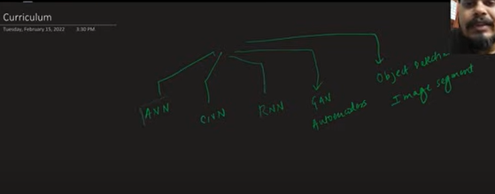

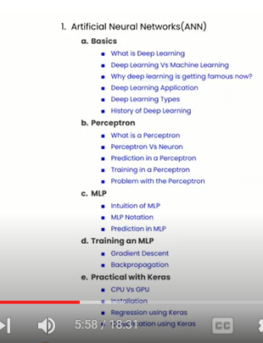

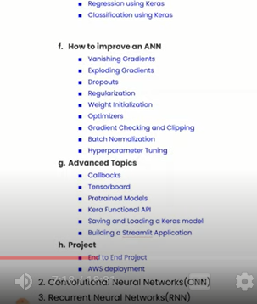

# **What is Deep Learning? Deep Learning Vs Machine Learning | Complete Deep Learning Course**

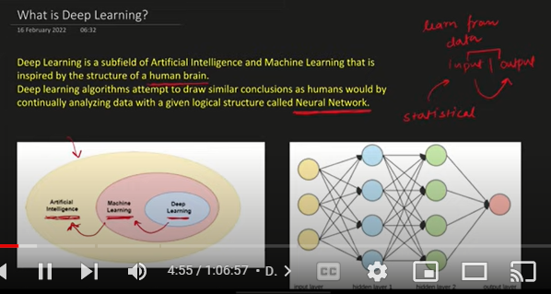

AI : It is a branch of study in which we are trying to make machines and robots do human work

ML: It is sub-branch of AI in which statistical techniques are used to gauge the relationship in datasets to predict outcomes

DL: It works on principle of human brain (neural networks) to predict outcomes

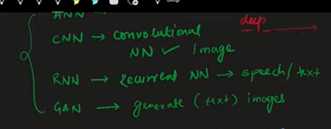

In ANN, there are multiple layers to predict the output. First layer is known as the input layer and there are several in between hidden layers and then there is an output layer

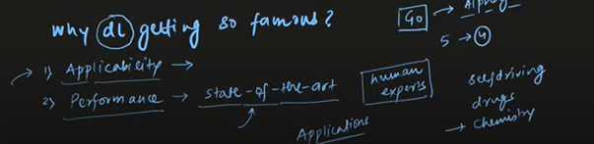

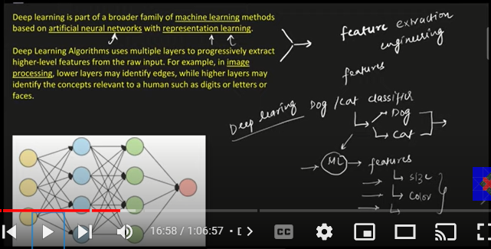

Deep learning is also known as **representation learning** where it extracts features automatically from image, texts and speech whereas in ML we used to extract features manually

The first layer extracts the primitive features and as we go on to several other layers more complex features are extracted

For eg in Dog, Cat classifier first the edges are identified, then in further layers shape and sizes are extracted

**ML V DL**

1. **Amount of Data**

DL requires more data in comparison of ML to give the better performance

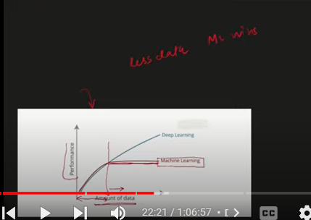

After some level of amount of data the performance of DL models start increasing significantly

1. **Hardware Dependency**

We need GPUs with greater processing abilities to run DL models, it runs slow on CPUs

1. Training time is high in DL as compared to ML
2. Feature selection is automatic, no need of domain knowledge

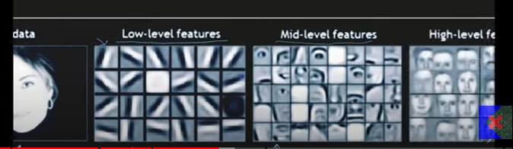

1. Interpretability: Internal operations are not transparent. We don’t know at what basis some objects are classified. It fails in cases of Explainability. But ML are explainable

Why now?

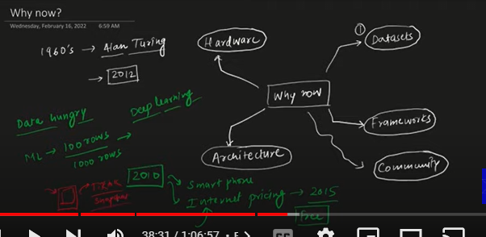

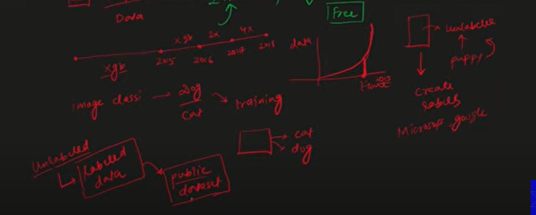

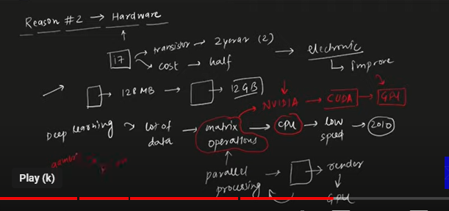

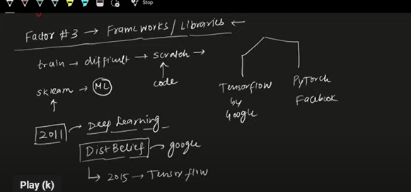

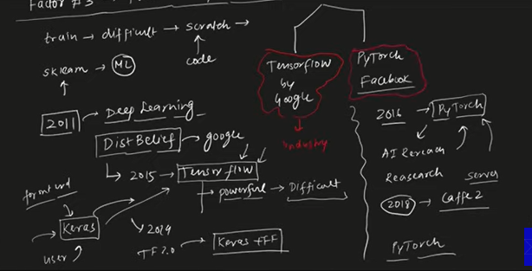

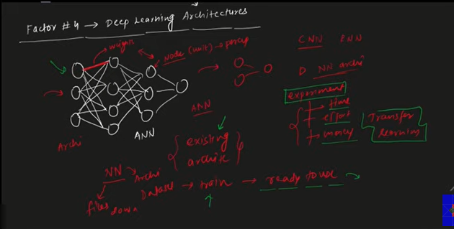

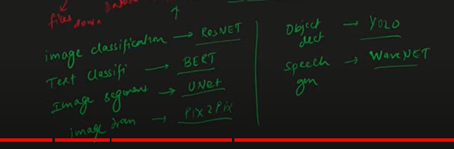

Transfer learning is way of applying existing architectures written by researchers to save time

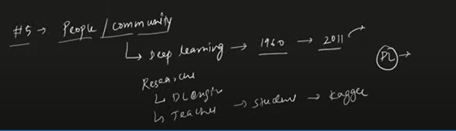

# **Types of Neural Networks | History of Deep Learning | Applications of Deep Learning**

1. Multi layer perceptron

There are multiple layers that are stacked (Input layer,hidden layer and output layer). Used in supervised problems

1. Convolutional Neural Network

Out of all the layers, one layer is convolutional. Used in images and video processing

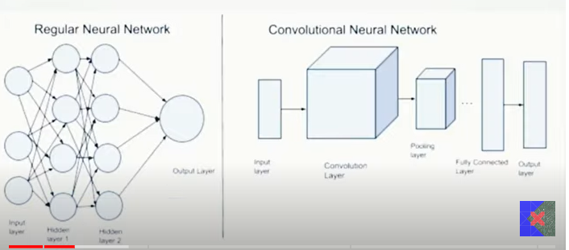

1. Recurrent Neural Networks

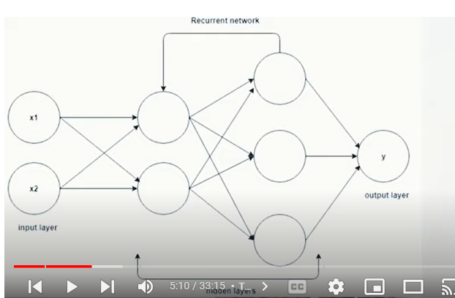

CNN and MLP both are feed forward neural networks. Information flows from first layer to last layer in linear way. IN RNN we can go in reverse direction as well

1. Autoencoders

Compresses the file without losing its quality

1. Generative Adverserial Networks

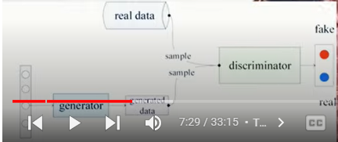

In GAN there is generator and discriminator. Generator generates the data and discriminator validates the data. Mostly used in images

GAN can also produce music and stories

For history watch:

<https://www.youtube.com/watch?v=fne_UE7hDn0&list=PLKnIA16_RmvYuZauWaPlRTC54KxSNLtNn&index=3>

Applications:

1. Self Driving Cars
2. Game playing agents
3. Image Colorization
4. Audio to mute videos
5. Image or video to captions
6. Text translation
7. Pixel restoration
8. Object detection
9. GAN producing images and music

# **What is a Perceptron? Perceptron Vs Neuron | Perceptron Geometric Intuition**

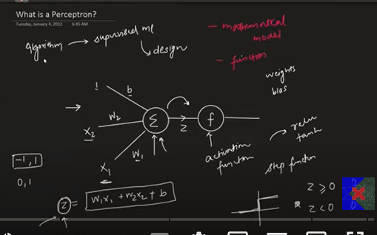

We provide inputs and w1 and w2 are the weights. From other we input 1 and b is is the biases.

Then output z = w1x1 + w2x2 + b comes out and moves towards the activation function and we receive the output value (0,1) accordingly

Activation function can be any function that transforms the output z to range of values

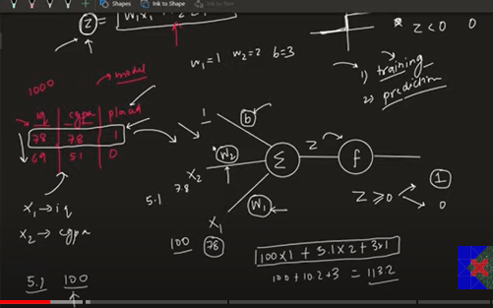

Step 1: We need good amount of data to train

Step 2: We train the data on the perceptron and find values of weights and biases and then calculate the value of z row wise and then apply the activation function

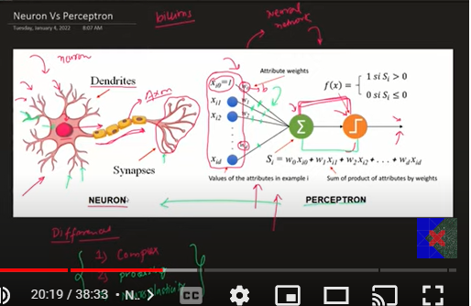

There are lot of similarities b/w a perceptron and neuron

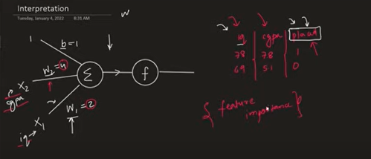

Weights tell us the feature importances

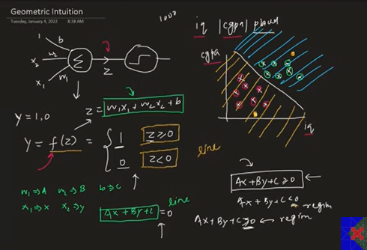

Perceptron is a line that is used to create two separate regions which then acts as a binary classifier.

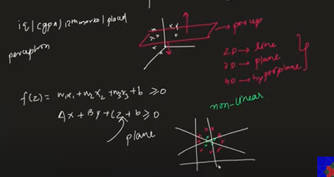

When there are more features, the line acts as a plane.

However, perceptron fails to work on the non-linear data and only sort of works when the data is linear

# **Perceptron Trick | How to train a Perceptron | Perceptron Part 2 | Deep Learning Full Course**

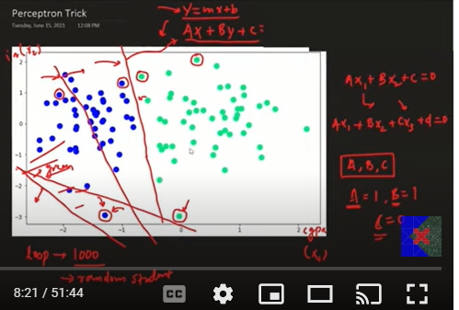

In perceptron trick we run a loop and classify the points based on if they are falling on the right side or not. We change the value of weights (A,B,C) in such a way that it classifies both the classes accurately

It randomly selects a point and asks whether you are falling on the right side or not

If the point is wrongly classified then perceptron will bring the line towards the point and if it is correctly classified it will go away from the point

We run the no.of epochs until 100 times or run while loop till convergence (when most of wrongly classified points are correctly classified)

When we increase the value of c then line goes up and when we decrease the value of c then line goes down

When we increase the value of A then rotation is clockwise (upside) and decrease in the value of A rotation is anticlockwise (downside)

So we change the value of A,B,C accordingly to cover the misclassified and if the point is misclassified it will pull the line towards it

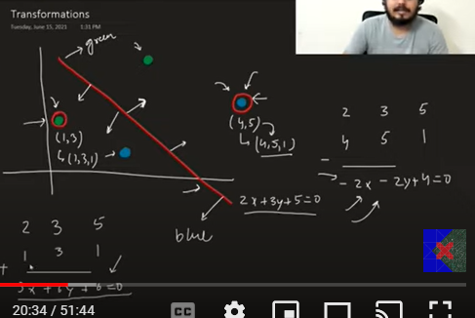

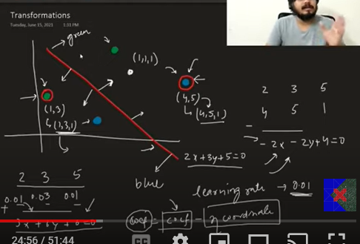

If the negative point is in positive region then we subtract the coefficients from the coordinates by taking 1 in z axis. If positive point is in negative region we add the coefficients with the coordinate of misclassified point

We directly don’t add the coordinates, we apply the learning rate to slow down the process

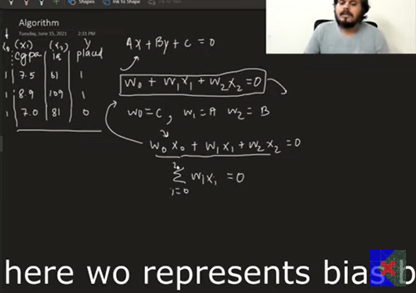

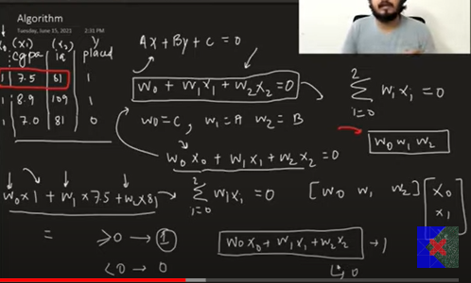

Now we will run the epochs, if the student is actually not placed (X E N) and wixi > 0 and algorithm predicts he’ll be placed then we will need to adjust weights accordingly

Same goes with other scenario

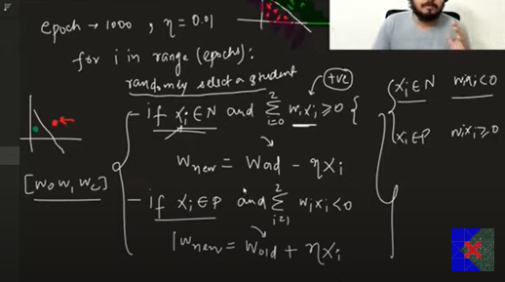

Now we combine both the equations to form a generalized equation

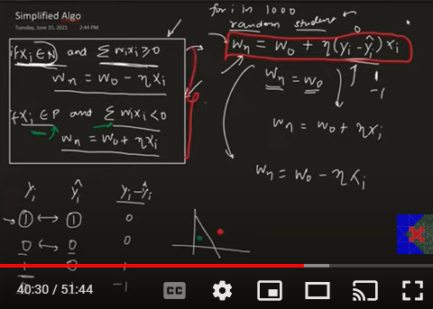

# **Perceptron Loss Function | Hinge Loss | Binary Cross Entropy | Sigmoid Function**

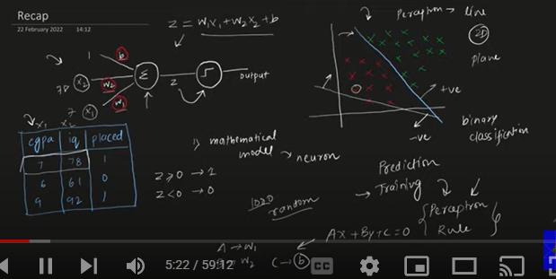

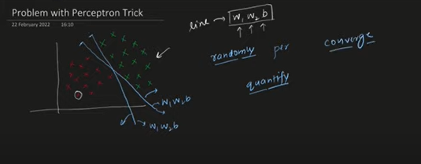

Now there are problems with perceptron trick:

1. We get random line that accurately separates both the classes. It stops checking once all the points are accurately classified
2. We can’t say which line is more accurate
3. Sometimes it won’t converge to accurate solution

To make it perfect we should know the loss function such that we can quantify the error

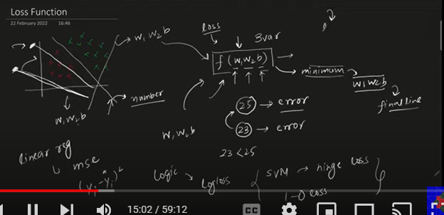

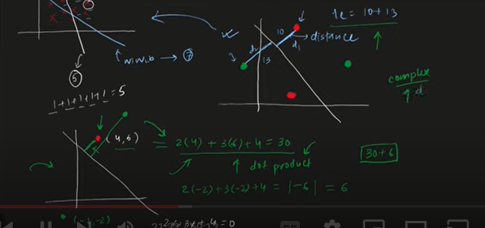

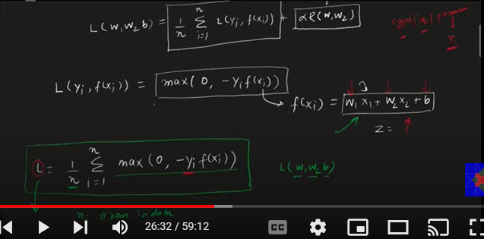

Loss function of a perceptron needs to be minimized for certain value of w1,w2 and b

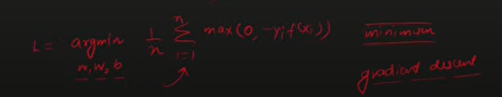

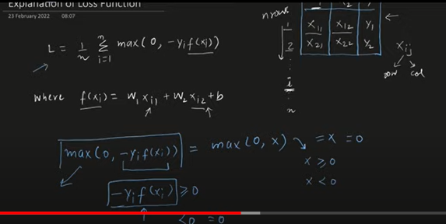

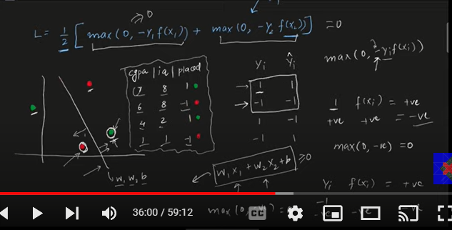

For the points that are correctly classified, the Loss function value contribution will come out to be zero.

On the flipside if the point is misclassified the loss value will come to be positive, hence there will be some contribution of positive value to the loss function

Correctly classified point will have zero contribution to the loss function

Now to converge to the minimum value of loss function we use Gradient descent

We initialize with some random value of w1,w2 and b and then run the epochs

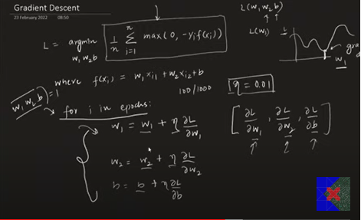

Now we calculate the partial derivatives for the gradient descent

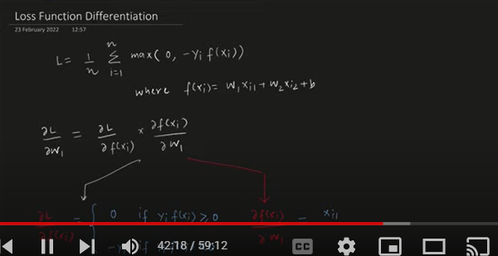

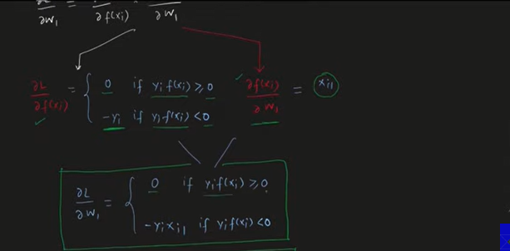

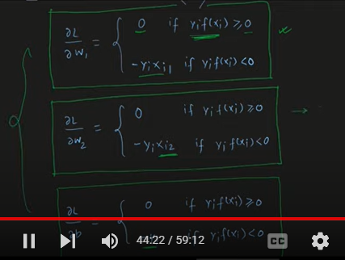

Perceptron behaves like a logistic regression if the activation function is a sigmoid and output comes to be a probability and Loss function is binary cross entropy

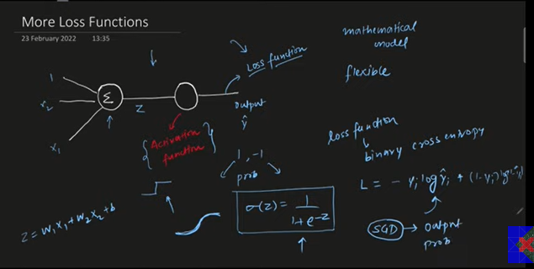

When there are multiple classes, the activation function used is softmax and loss function used is categorical cross entropy

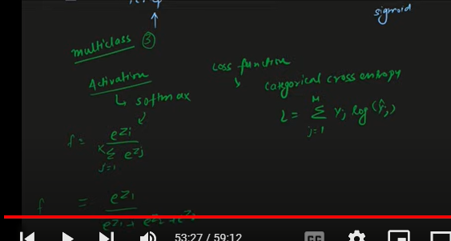

When the activation function of the perceptron is linear (i.e. the output remains the same after coming from z = wixi + b) and loss function is mse or mae then it is a case of linear regression

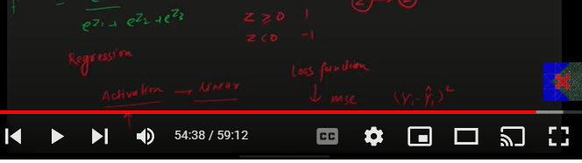

Summary:

The below summary is for stochastic Gradient descent

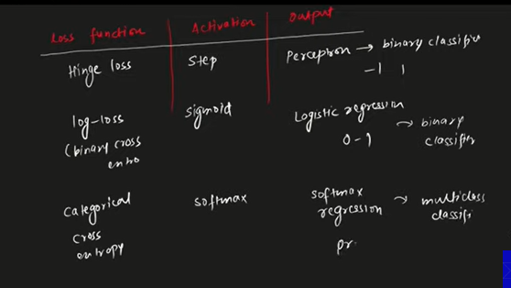

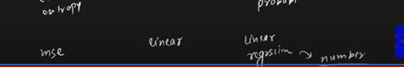

# **Problem with Perceptron**

<https://colab.research.google.com/drive/1x6detmf4WAUAT2pfdCts-dVrqnz4_gNB?usp=sharing>

The problem with perceptron is that it cannot linearly separate the non-linear data like xor data. It works fine only on the linear separable data

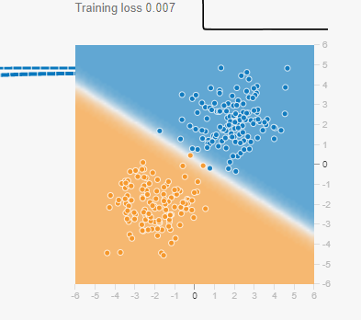

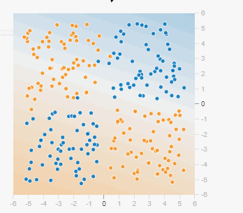

# **MLP Notation**

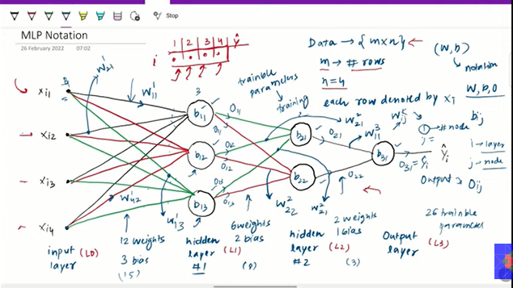

We have three major coefficients notations to worry about: Outputs, weights and biases

# **Multi Layer Perceptron | MLP Intuition**

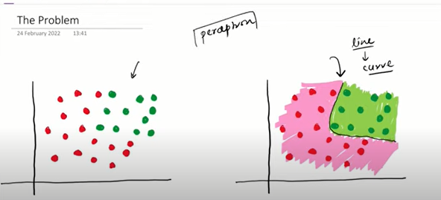

The problem at hand is that the perceptron cannot separate the non-linear data. But we want perceptron to separate the non-linear data

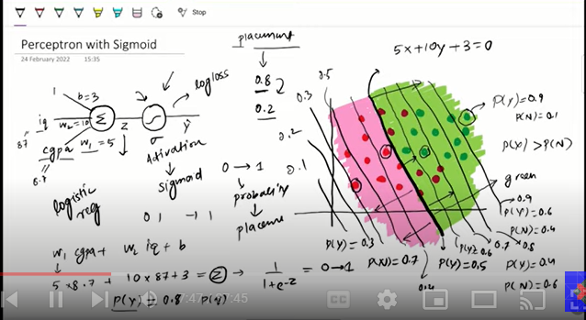

Abstract Idea of MLP:

On a given dataset we take two perceptrons and then superimpose them and then at last combine both of them (smoothen their boundary)

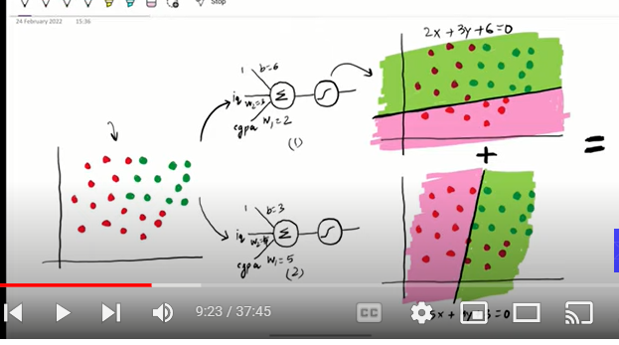

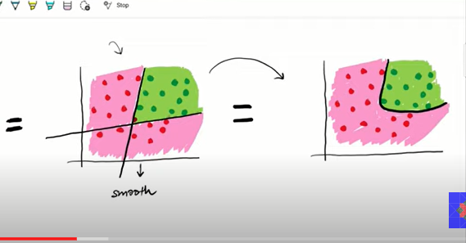

Mathematical formulation:

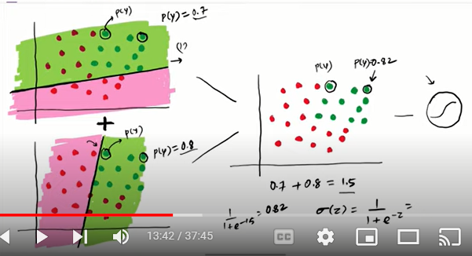

We add the probability of same datapoint and then apply sigmoid function on top of that

Another scenario where we want the influence of first perceptron to be more, then we apply weighted additions of the probabilities

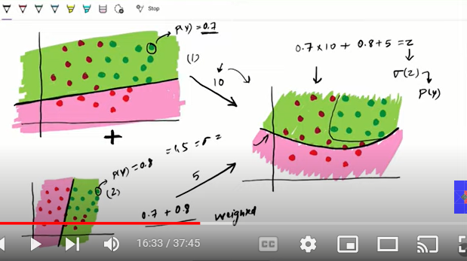

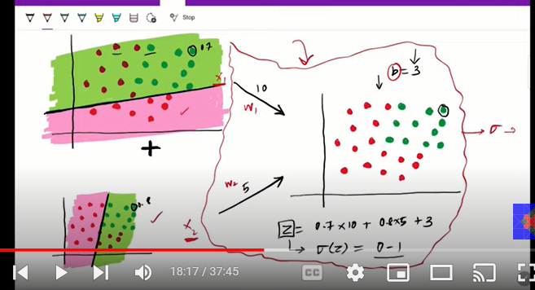

Now what we are doing is that we are adding three perceptron in a way to achieve our combination

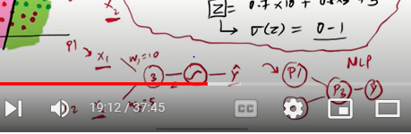

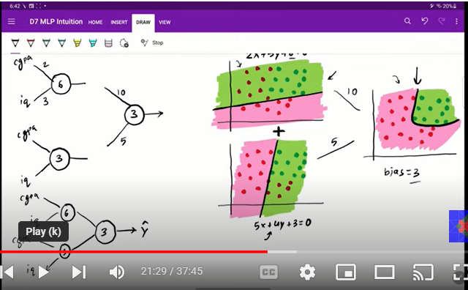

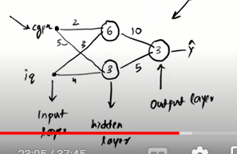

As we increase more perceptron in the hidden layer we can make more complex non-linear decision boundaries

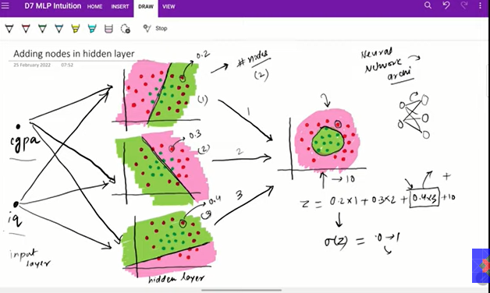

When there are more input columns the dimensions will increase and the perceptron line will become a plane

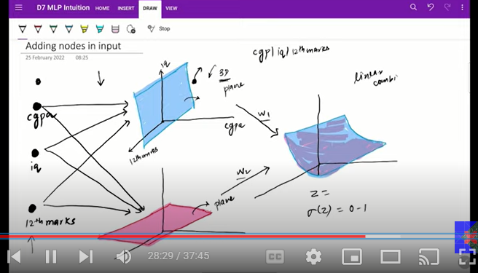

We can add more output layers for multi label classification

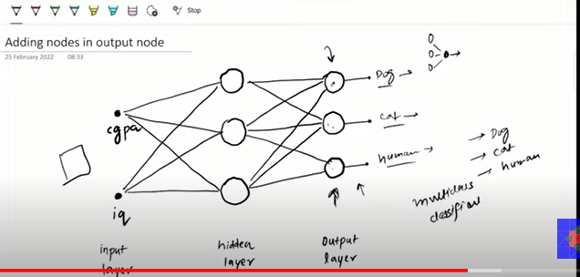

Another instance is when we add more hidden layers to capture more non-linearity

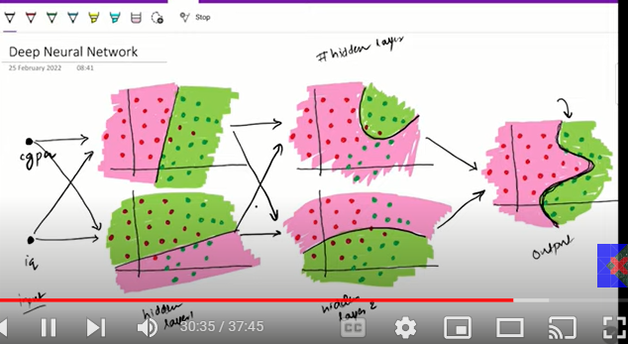

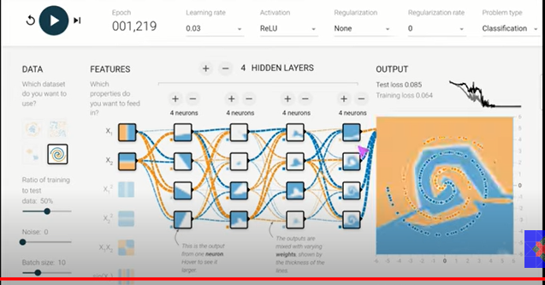

# **Forward Propagation | How a neural network predicts output?**

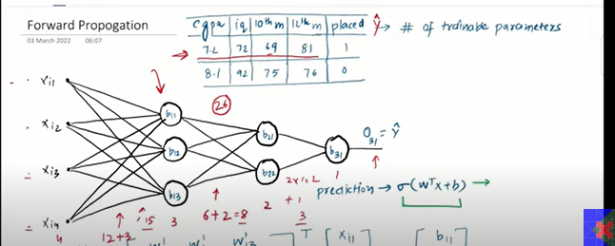

Now we create a matrix of all the weights (w) and input values and the bias of each nodes

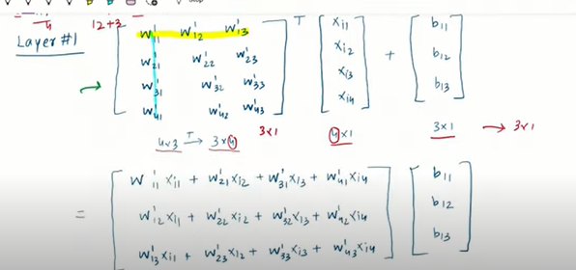

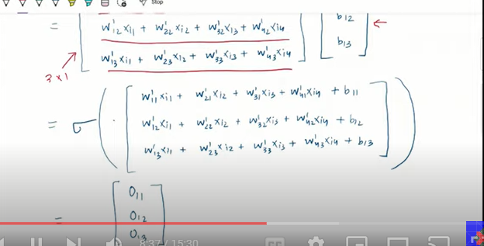

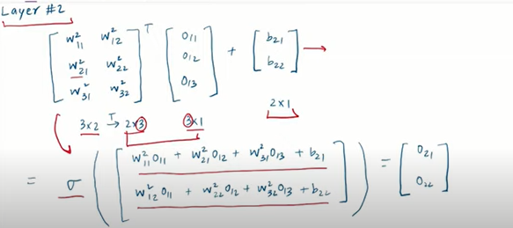

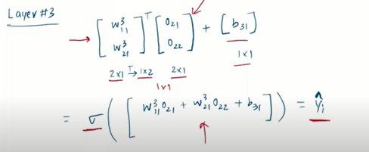

A[0] is the matrix of input values, a[1] is matrix of output values from first layer

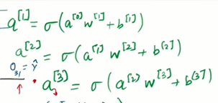

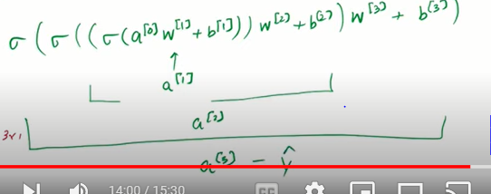

# **Loss Functions in Deep Learning - Explained**

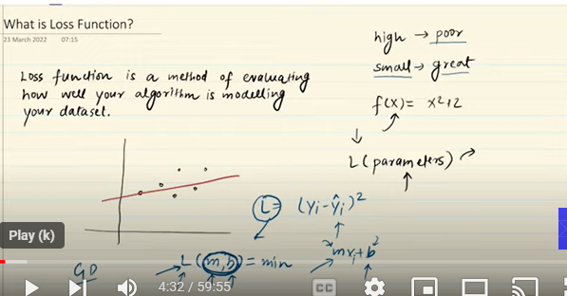

Loss function in any model is way to check the performance. It is a function of the hyperparameters and in deep learning it is weights and biases through which we change the values w & b to find the best fit line with minimum errors

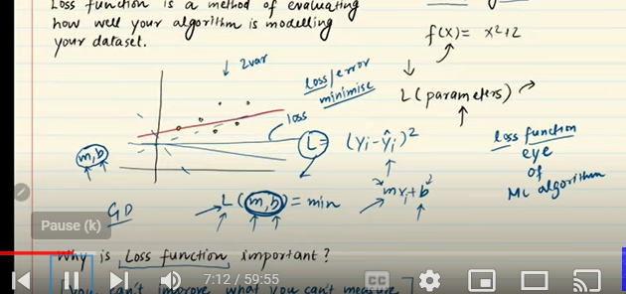

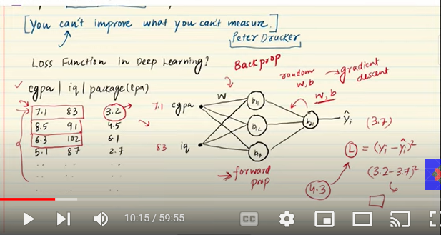

In this process, we will use the forward propagation and input the values of input columns into the layers with random weight and biases. Then when we receive the output we calculate the error using the loss function. Then we again back propagate and change the value of weight and biases and the recalculate the error. This process goes until the error is minimized using the gradient descent in multiple epochs

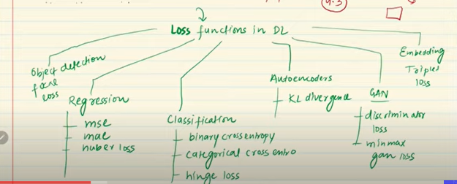

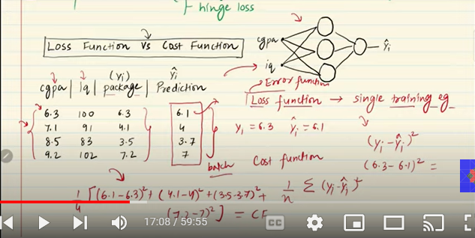

Loss function calculates the error in prediction for each row, while cost function calculates the error of whole dataset by taking the average of all the errors received from each row

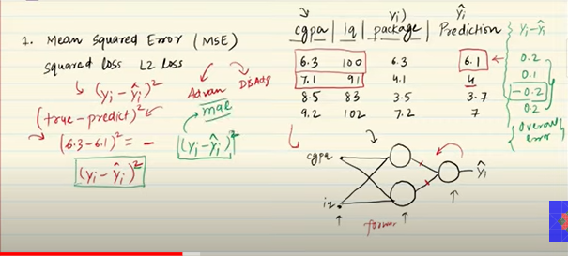

We calculate the error for each row one by one and then update weights and biases to minimize the error

Now the error can be calculated by simply ypred - y. But some values will be positive and -ve and that will reduce the total magnitude of errors

So we consider square of errors,In this scenario when the error is high the change in weights and biases will be very high and drastic as compared to when errors are low. The reason being the higher error are being punished due to quadratic nature. The line moves faster towards the point having more error as we studied in perceptron

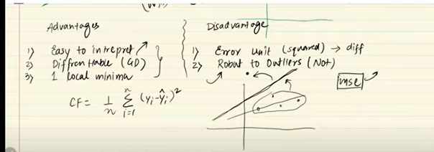

Activation function should be linear when applying mse

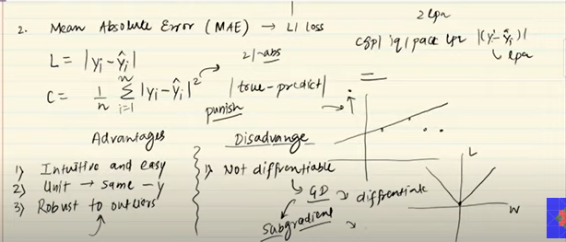

If data has outliers, then we use mae

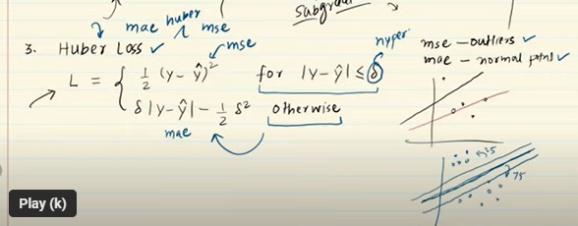

Huber loss is helpful when certain proportion of values are outliers and we want to find the balance b/w mse and mae. Mse will try to cover outlier and hence miss out on actual points and mae will not cover the outlier points. So we try to find a balanced line which is in b/w both mse and mae line

So we use combinations of two equations in this case, mae to cover normal points and mse to cover outliers

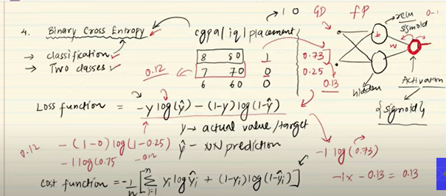

We calculate the loss by substituting the values coming from sigmoid (y_pred) and actual y values and then we update the bias and variance using GD depending upon the magnitude of error

The output layer should have activation function as sigmoid

It is also known as log loss

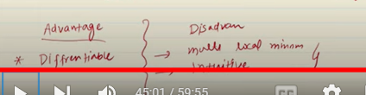

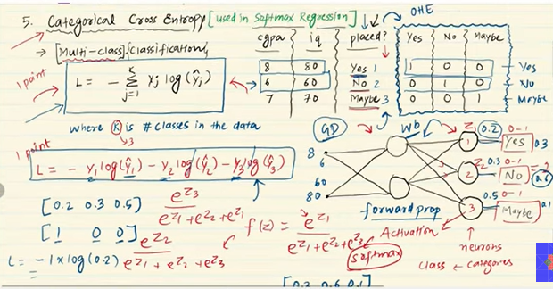

Activation function should be softmax of output layers

In case of multiclass classification, the output layer has n number of neurons based on n classes

We first one hot encode all the categorical classes

Then calculate the loss value for each row using forward propagation. Then change the weights and biases by back propagating (GD) depending upon the magnitude of the error

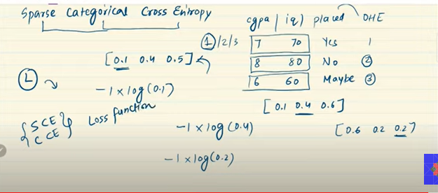

In sparse categorical entropy. Instead of one hot encoding we label encode the target values

It works in the similarly to Categorical cross entropy, but in this case w only calculate the loss of the one category that is the output instead of calculating for all possible scenarios

This works faster as compared to CCE due to less number of columns and we are not calculation multiple logs

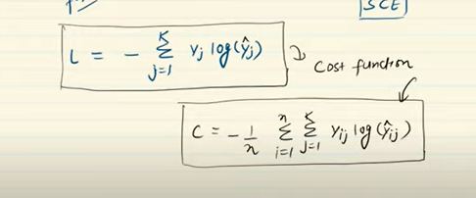

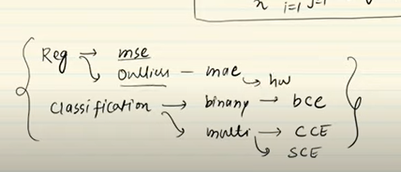

# **Backpropagation in Deep Learning | Part 1 | The What?**

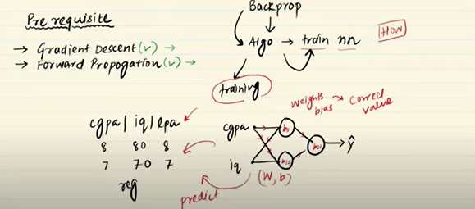

Backpropgation is way to train the neural network architecture. The goal is to find the optimal weights and biases using Gradient descent

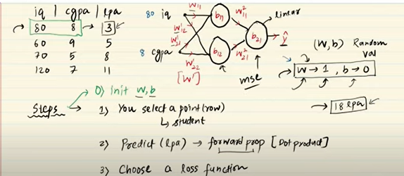

Now since we are initializing with a random value of w and b, there are higher chances that the output received would be highly erroneous

So our aim is to reduce that error using back propagation

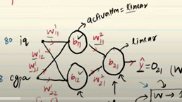

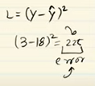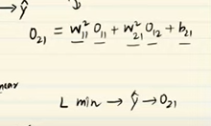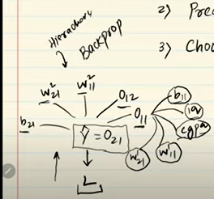

Now, to reduce the error we cannot change the y value as it is the data. However, we can change the the value of yhat or ypred which further depends on the wholesale numbers of

Weights and biases that we can back propagate to change the value of all these weights and biases to get minimum error

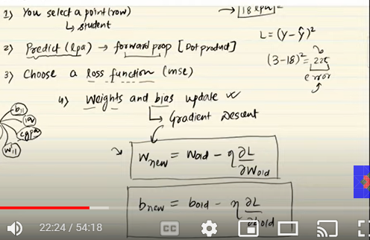

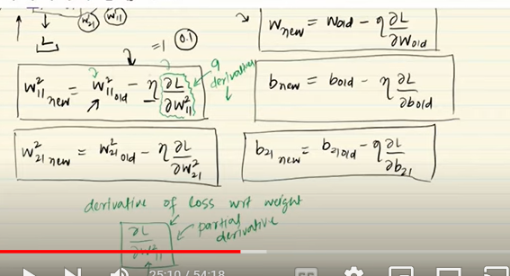

We have the value of w11 =1 for start and know the value of of learning rate. But what we need to calculate is partial derivative to complete the algorithm

Now the point is we cannot calculate the partial derivative of loss function w.r,t the weights. We first calculate how much change there is in ypred when we change the coefficients (dL/DY) and then calculate change in loss with change in ypred (dw/dY)

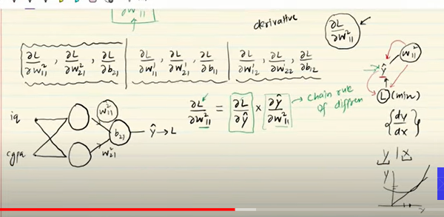

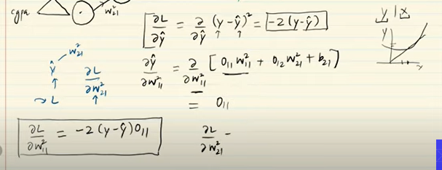

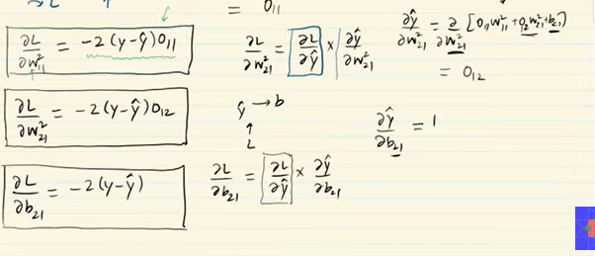

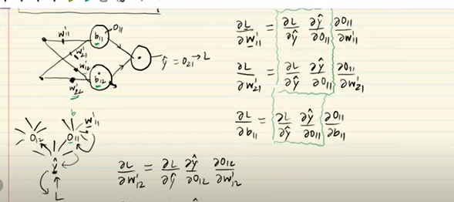

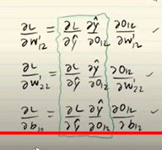

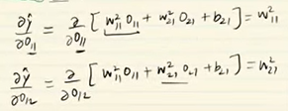

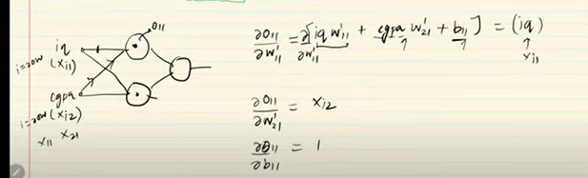

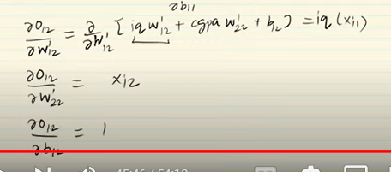

Substituting the values of derivatives:

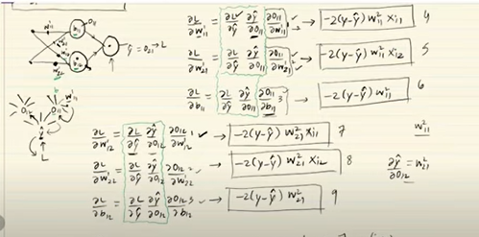

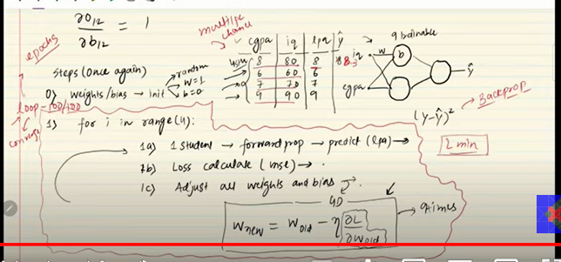

# **Backpropagation Part 2 | The How | Complete Deep Learning Playlist**

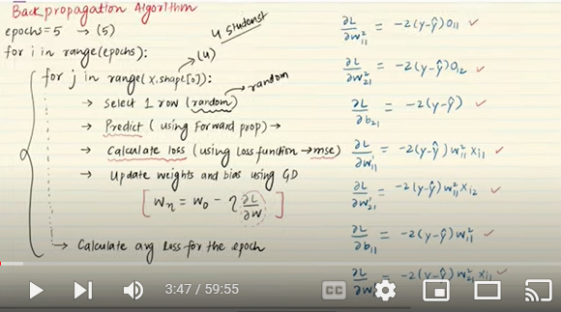

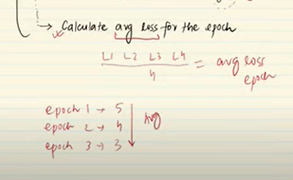

# **Backpropagation Part 2 | The How | Complete Deep Learning Playlist**

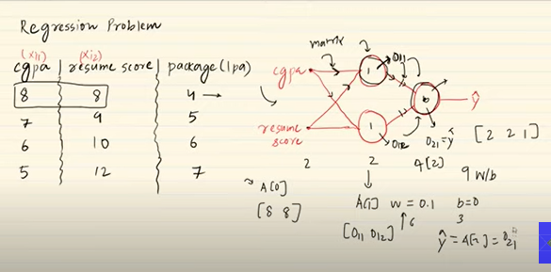

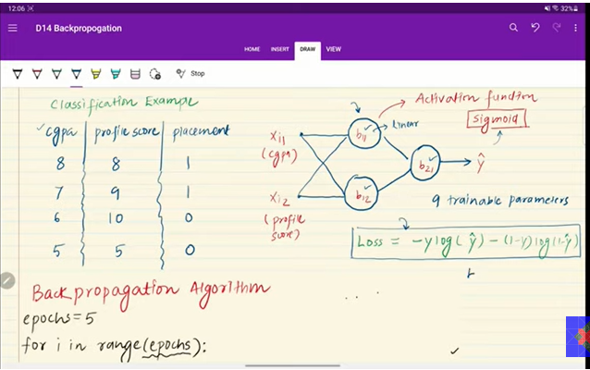

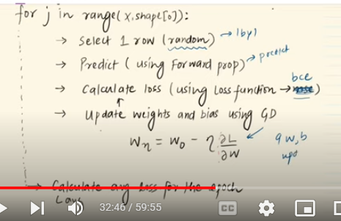

Now calculating derivatives for all the weights and biases

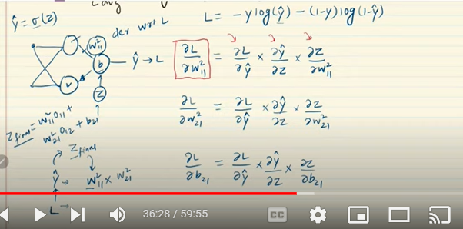

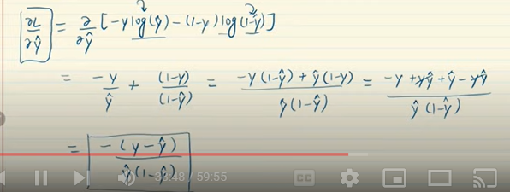

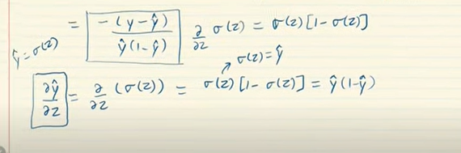

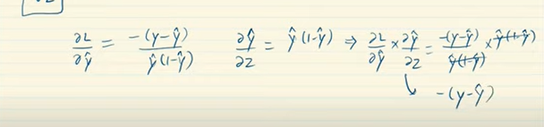

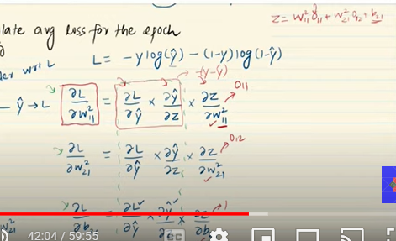

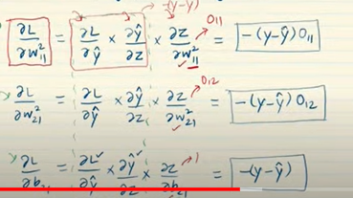

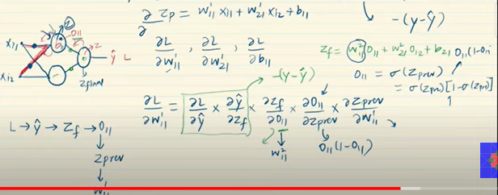

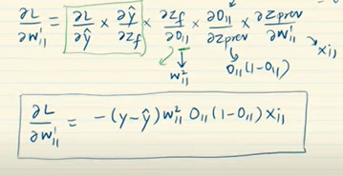

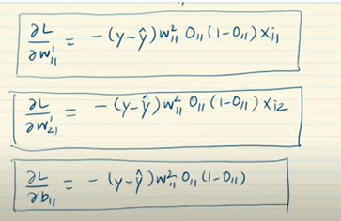

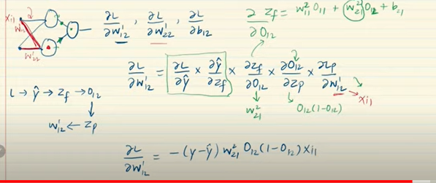

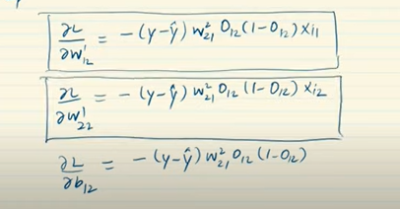

# **Backpropagation Part 3 | The Why | Complete Deep Learning Playlist**

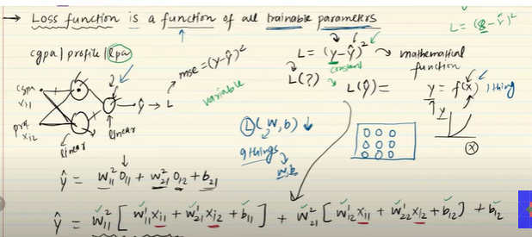

So apparently Loss function is a function of all weights and biases, whose values are tuned to get the minimum loss possible (In case of 3 neurons 2 hidden layers and one output layer with two input layers we get 9 trainable parameters)

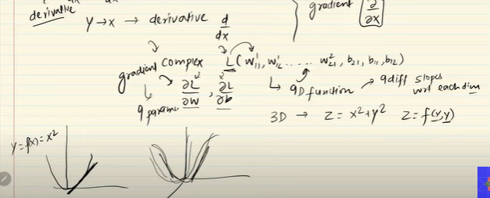

Gradient is the partial derivative of all the trainable parameters. In case there are 9 different parameters, we will calculate 9 partial derivatives

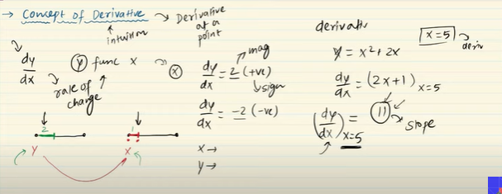

Derivative tells us how much y varies with change in value of x

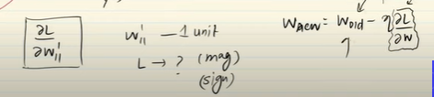

This equation tells us that with unit change in w111, how much change is there is magnitude of Loss

That’s why we try to reduce the w with the change in loss

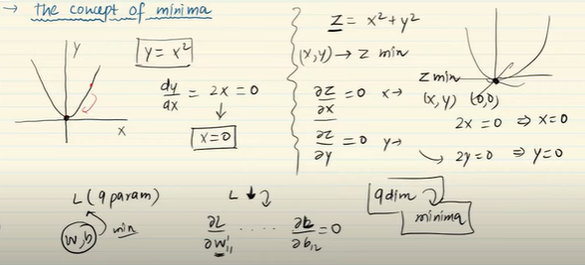

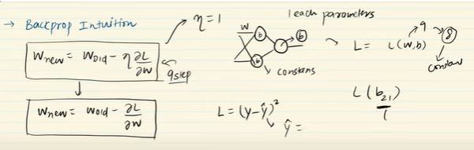

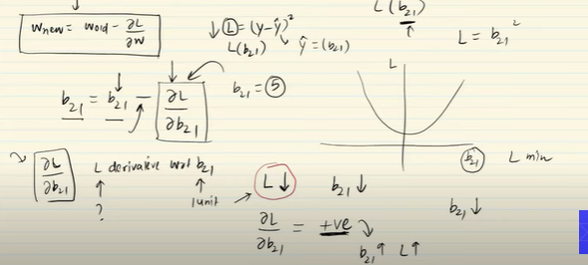

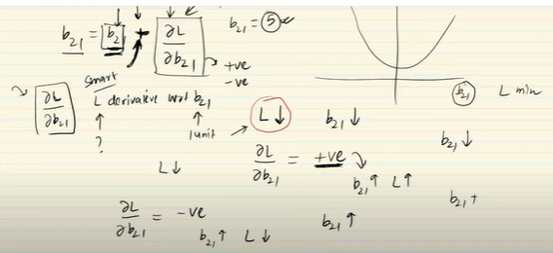

So when the dL/db21 is positive, it implies that with increase in value of b21 the Loss increases and hence in formula we will reduce the actual value of b21 by subtracting it from the slope (the amount the loss increases with increase in b21)

When dl/db21 is negative, it implies that with increase in b21 the loss decreases and hence in formula we will increase the actual value of b21

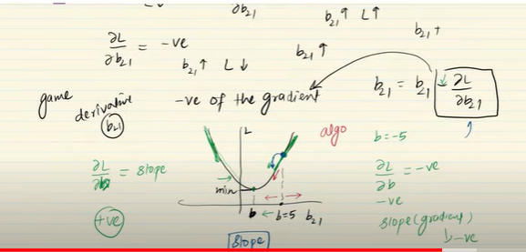

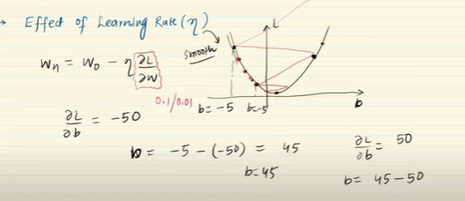

Learning rate are considered to smoothen the process of converging. Higher learning rate will shoot out the curve in zig zag motion and lower learning rate will take lot of time to converge to global minima

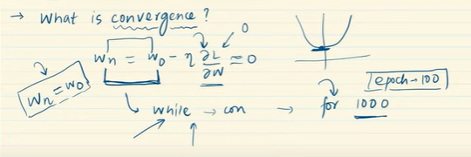

# **MLP Memoization | Complete Deep Learning Playlist**

Memoization is way to store the code output in order to avoid repeated operations to be processed again and again which takes a lot of computational power and time

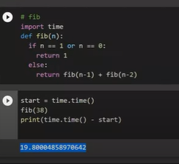

In this fibonacci code to calculate fibonacci of 38, fibonacci of each number is recalculated again and again which consumes a lot of time

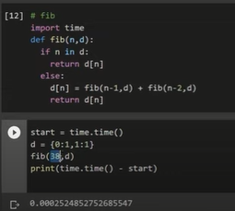

Storing the individual value of fibonacci in a dictionary will save us a lot of time

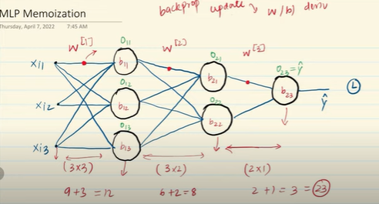

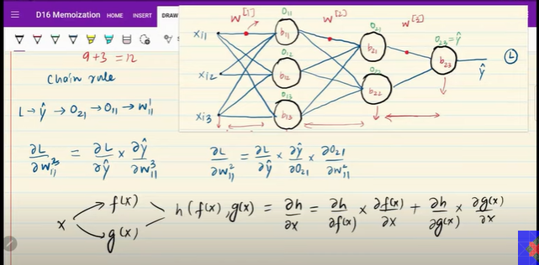

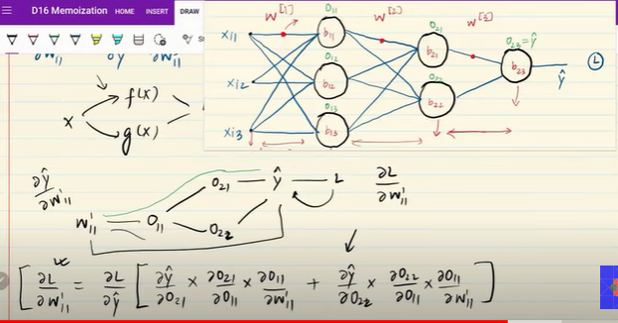

Calculating the derivative of the weights of first layer is tricky as there are two functions that can be possible. (O21 and O22)

So we calculate the partial derivatives of both of them add them separately

In this scenario, there are lots of derivatives that can be reused and the best practice is to store or memoize them to reduce the computational power

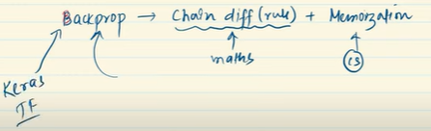

# **Gradient Descent in Neural Networks | Batch vs Stochastics vs Mini Batch Gradient Descent**

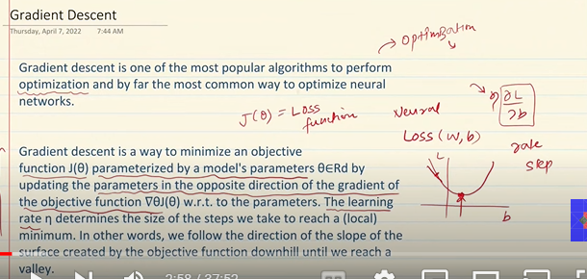

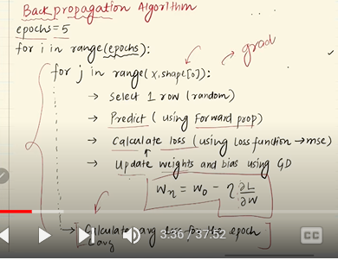

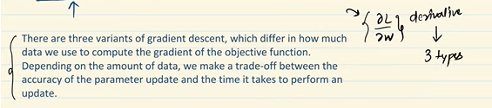

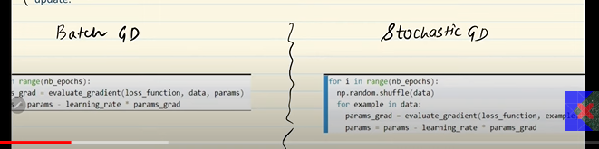

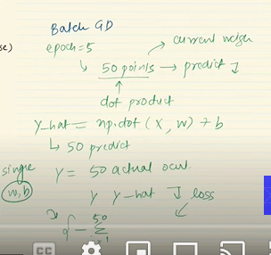

**Batch gradient descent**

In batch gradient descent, we don’t run the epoch on each row one by one instead we for each epoch we calculate the weights and biases on whole data at once by directly doing dot product on all the rows in form of array

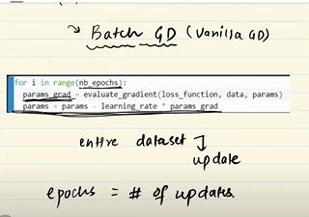

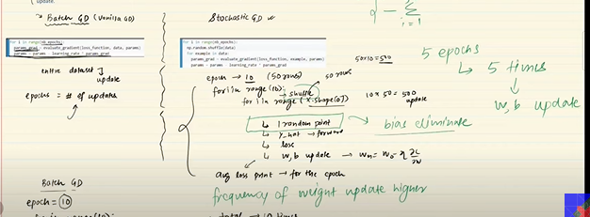

Whereas, Stochastic GD runs the loop on each and every row for each epoch and the weights and biases the times there are number of rows

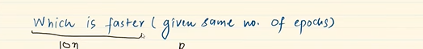

Batch GD is faster as compared to Stochastic GD as it updates weights and biases once for each epoch



Stochastic GD will converge to correct solution more faster as compared to batch GD as it runs over on each row and has multiple iterations

How smoothly the Batch GD and Stochastic GD converge?

Stochastic:

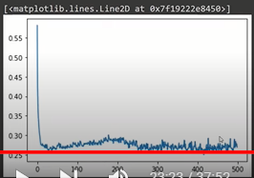

Batch GD:

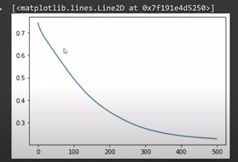

The loss decreases in unstable manner in stochastic GD while decreases smoothly in case of batch GD

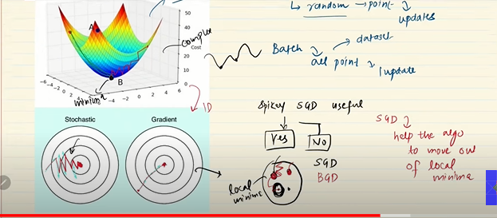

The zig-zag motion in stochastic GD comes from randomness

Advantages/disadvantages:

1. If there are lots of local minima and a global minima in a curve, stochastic won’t get stuck in the local minima’s due to it’s random nature while batch gradient which moves smoothly will not be able to come out of the local minima due to its smooth nature
2. However, due to it’s zig zag nature, SGD won’t converge to exact global minima and it will only be able to converge to approximate solution
3. Vectorization: In batch GD, we can replace the loop of all the rows with the dot product of vectors which is smart and faster way to calculate the y_hat. But, if the dataset is huge with millions of rows. It would require huge computational power and that won;t be feasible

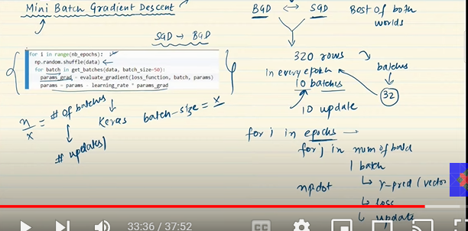

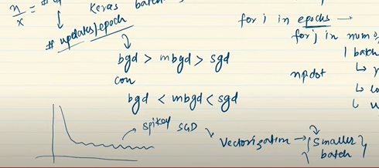

In terms of updates/completion of epochs, batch gradient descent is faster as compared to other two and for convergence to correct solution it is vice versa

Mini batch gradient descent is best of both worlds, it uses vectorization to some extent is relatively faster and the batch sizes are relatively small so computationally it works fine

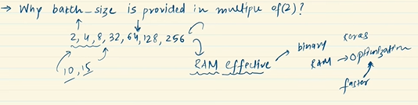

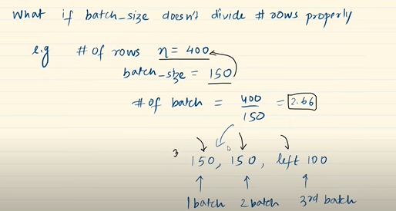

# **Vanishing Gradient Problem in ANN | Exploding Gradient Problem | Code Example**

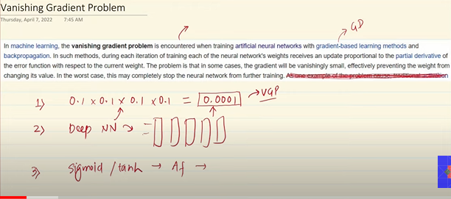

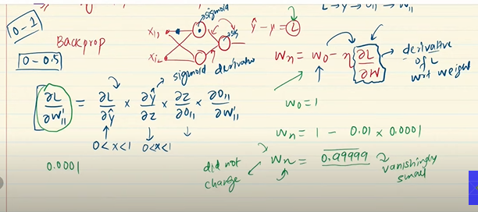

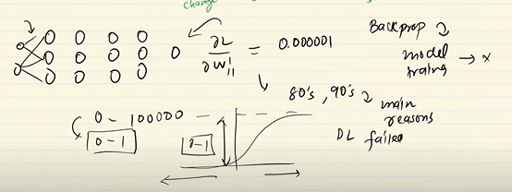

When there are a lot of neural networks, if the value of new weight after applying gradient descent is too low (due to sigmoid function), then the change will be infinitesimally negligible and there will be no training further

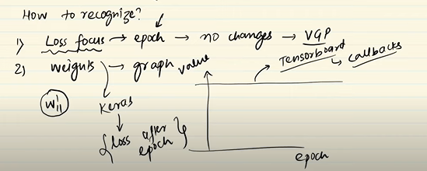

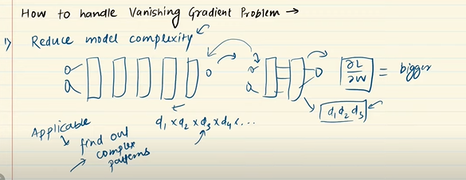

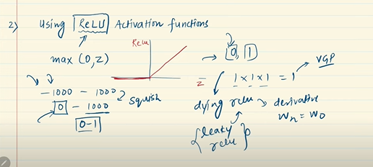

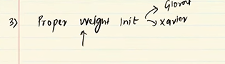

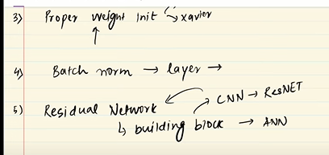

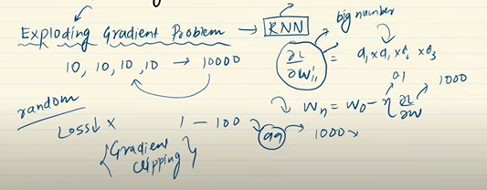

# **How to Improve the Performance of a Neural Network**

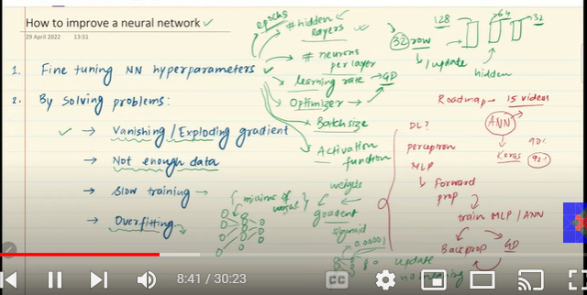

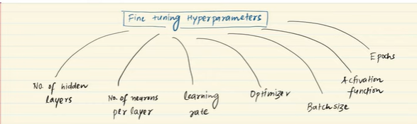

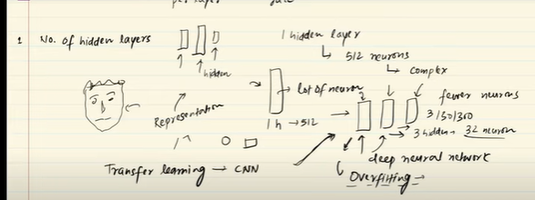

Instead of putting multiple neurons in a single layer, we distribute neurons in multiple hidden layers. It is the intuition that multiple layers can capture the complex patterns easily as compared to single layer.

How much hidden layers we should have?

We experiment and check at which number of layer the overfitting starts. We keep only that much hidden layers and stop adding anymore hidden layers

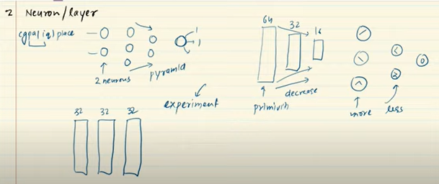

Previously, it was thought that number of neurons in the hidden layers follow the pyramid structure with first hidden layer (which captures primitive structure) consisting of more layers and second (which captures more complex structure) consists of slightly lesser and so on.

But later it was observed that number of neurons in a layer doesn’t affect the performance. WE can also keep same number of neurons for each layer

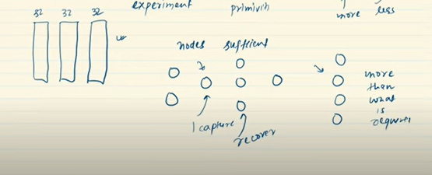

So, we always start with more number and neurons and optimize the number later on based on the overfitting

We never start with less number of neurons as it might fail to capture primitive features

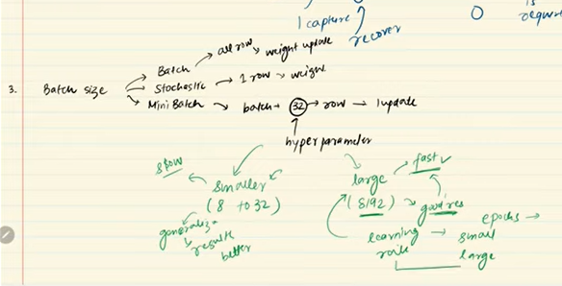

We can also change the batch size of the data that we provide to get better results

Smaller batch size (in mini-batches) gives the accurate results but are slow

Larger batches tends to be faster, but sometimes doesn’t converge to accurate results.

But it is seen that keeping learning rate smaller for initial epochs and gradually increasing it when we are proceeding with higher epochs tends to give better results (warming up the learning rate) and is preferable

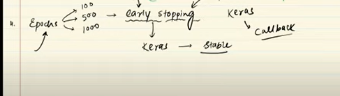

We can change the number of epoch values to converge to right results.If we are not sure about how much epochs we should keep, we use early stopping method (Keras callbacks) which stops the epochs when it observes that performance stabilizes and there is no such improvement

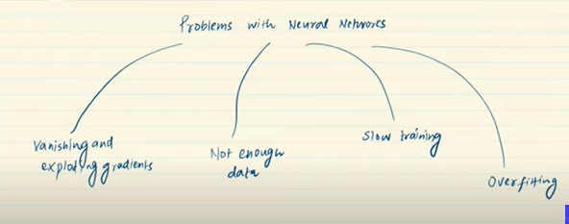

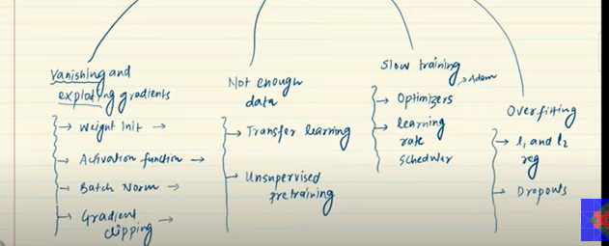

# **Early Stopping In Neural Networks | End to End Deep Learning Course**

Early stopping is automatic feature that is used to reduce the overfitting at some epoch value by itself

<https://colab.research.google.com/drive/1JG6PCAa5A0-CLOcKhugqU4uyZXWNjtKP?usp=sharing>

# **Data Scaling in Neural Network | Feature Scaling in ANN | End to End Deep Learning Course**

When there are columns with different units and level of magnitude varies, the neural network might give poor results because the training becomes slow and the solution may not converge to correct solution

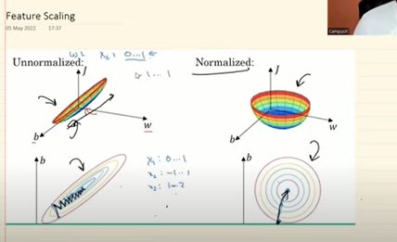

When the features are unnormalized, loss function will be unsymmetrical and it would not be easy for back propagation algorithm to back traverse easily

In case of normalized data, the loss function will be symmetrical and it will be easy to traverse for back propagation. Gradient descent will easily converge

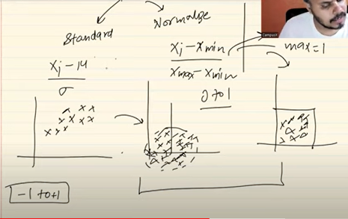

https://colab.research.google.com/drive/1lexRUY37fJd6op-WiJicPRB65PwA8YaO?usp=sharing

# Improving Neural Network Performance

<https://docs.google.com/document/d/1YjuG6xj10ALmltbEqmxu1wOBWMIV5BU2DmVP05xlZ3c/edit#heading=h.nrdm1gylm3c6> (All the techniques)

# **Dropout Layer in Deep Learning | Dropouts in ANN | End to End Deep Learning**

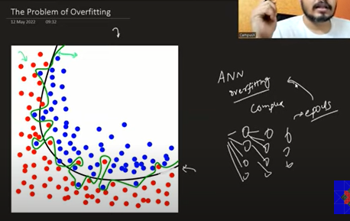

ANN are most prone to overfitting reason being there are multiple hidden layers that can lead to complex decision boundaries

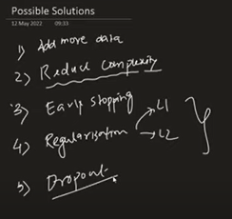

Adding more and different type of data may help in reducing the overfitting.

Reducing complexity (reduce the number of hidden layers and number of internal neurons) may work too

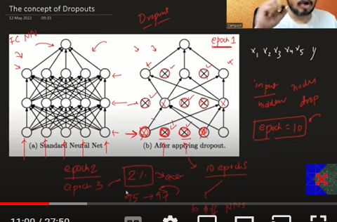

In dropouts, we drop random neural nodes in each hidden layer for one epoch and train them and then on second epoch we drop some other random neural node in each hidden layer and then train the whole neural network

This tend to increase the accuracy by 2%

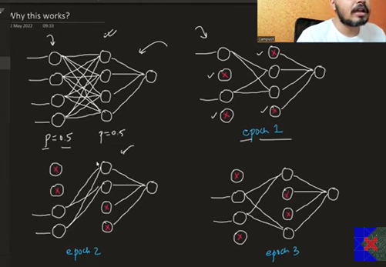

The idea behind dropout is two folds:

1. First reducing the number of nodes which simplifies the network and it doesn’t capture all the minute relationships and complex patterns
2. We are removing the nodes randomly so that they cannot focus on single type of pattern (coming from only one node) only and focus on all type of patterns equally

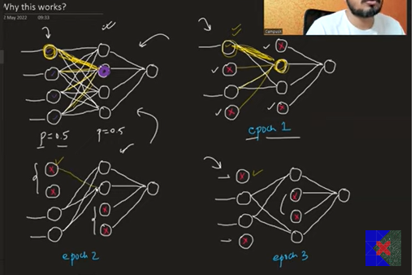

Now instead of focusing on only one node, it focuses on other node equally as the first node might not be in other epoch

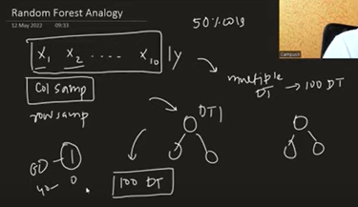

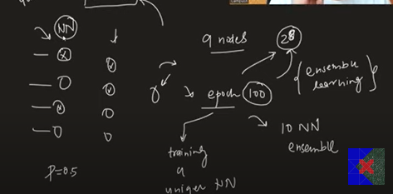

Dropouts are also somewhat similar to Random Forest, here we work on principle of ensemble learning. On first epoch we consider some nodes and then train them on second epoch we train some another nodes (some might be the same) and at the end we combine the results through voting or mean of all the epochs to reach to a result

So, dropouts also reduces the overfitting just like Random Forest reduces overfitting

Now, the question is when we use the dropouts there might be chance the weights might be different from the network if we trained all the nodes

We only drop nodes during training but during testing we keep all the nodes. So, the weights won’t be same in both the scenario. To maintain this consistency we multiply the weights in testing set with the probability of that node to be trained. For eg we are dropping nodes with p=0.25, so the probability of that node to be available and tested will be 0.75

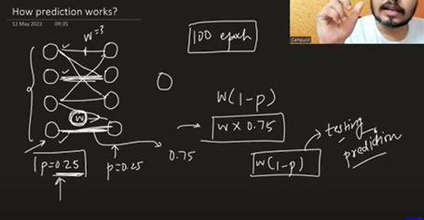

# **Dropout Layers in ANN | Code Example | Regression | Classification**

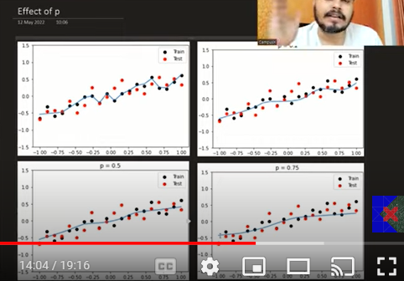

The optimal value of p = 0.2-0.5 else its overfits or underfits

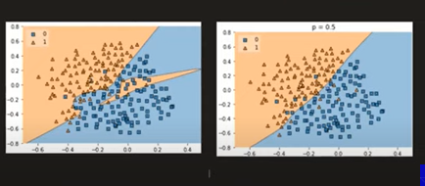

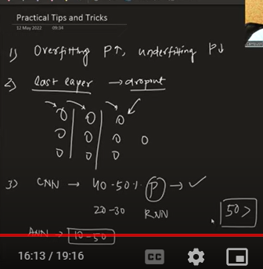

Higher the value of p more underfitting and lower the value of p leads to overfitting

We first apply dropout on the last layer before the output layer and check if it gives better results

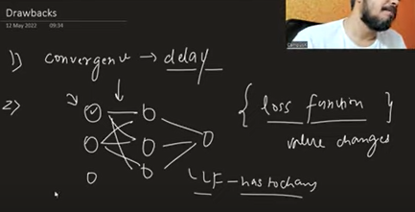

With dropouts there are chances of delay in convergence of correct values of weights and biases

The value of loss function changes with introduction of dropouts which creates a problem in tracking the value of gradients

# **Regularization in Deep Learning | L2 Regularization in ANN | L1 Regularization | Weight Decay in ANN**

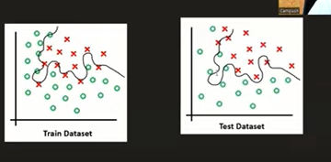

What is overfitting?

Overfitting is scenario when the model performs well on the training dataset and but the performance on test dataset is not at all good

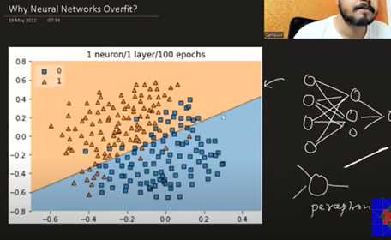

When we only add 1 neuron/ or perceptron it will directly draw a decision boundary which will be a straight line

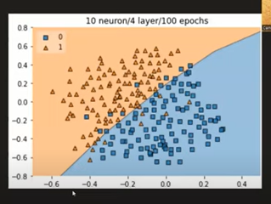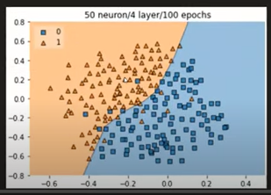

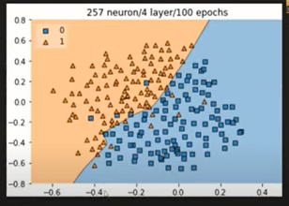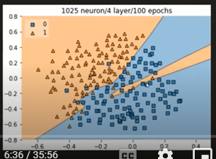

Now, as we make the model more complex, it tends to capture more complex relationships in the data. If there are more neurons (it can draw more complex lines), it might capture smaller patterns in the data instead of capturing essence of data